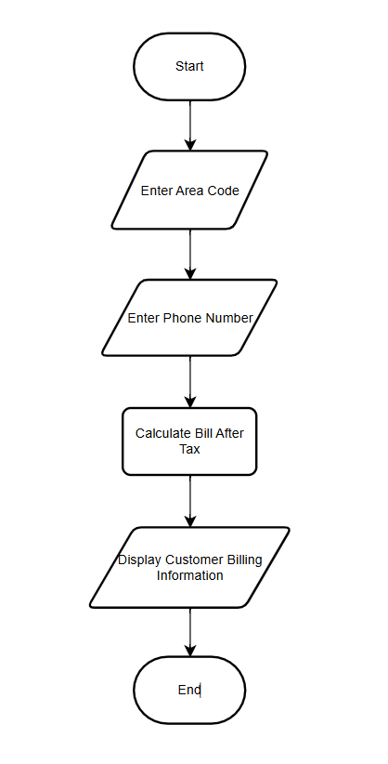
Flowchart 1: Single Customer Billing Calculation
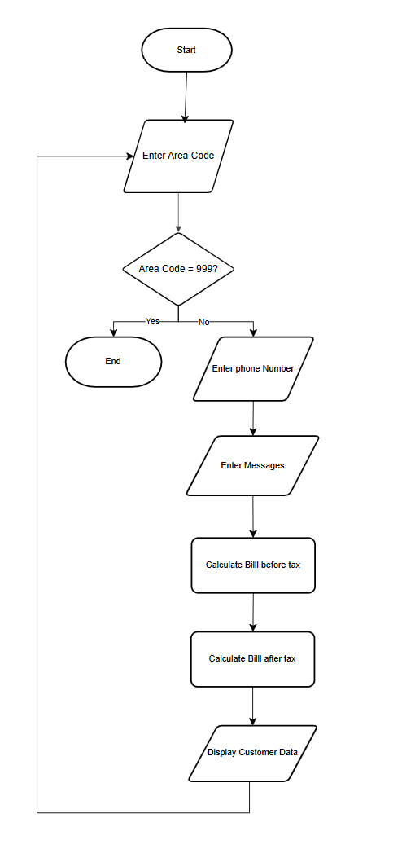
Flowchart 2: Continuous Input and Display of All Customer Data

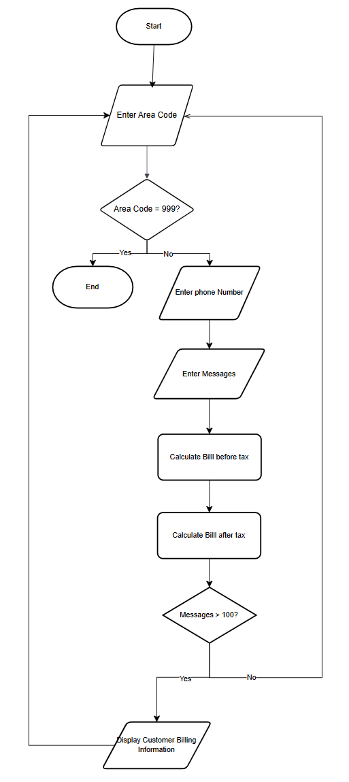
Flowchart 3: Display Customers with More Than 100 Messages

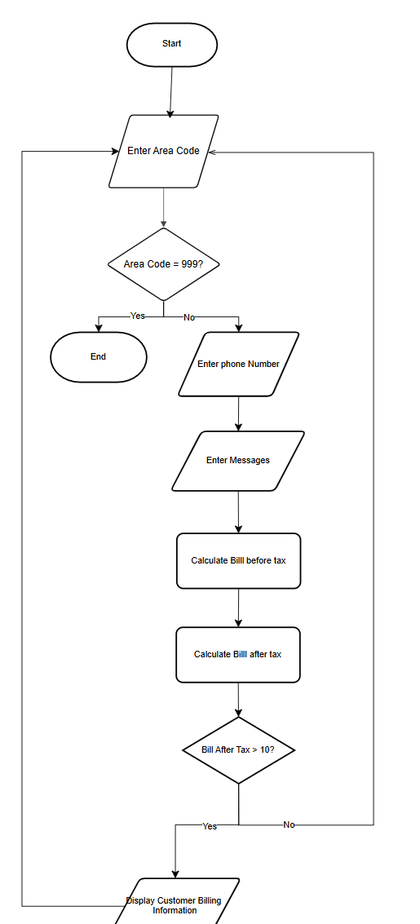
Flowchart 4: Display Customers with Bills Greater Than $10

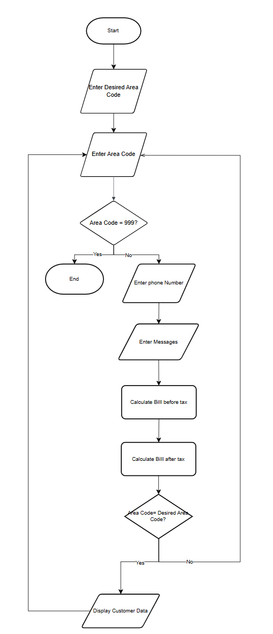
Flowchart 5: Filter Customers by Area Code

